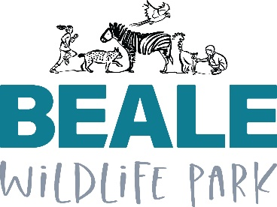 | Equal Opportunities Policy

Beale Wildlife Park Equal Opportunities Policy | Owner: Nikki Slade (HR)

The Trust is an Equal Opportunities employer. We will ensure that there is no discrimination against anyone applying for a job or whilst volunteering or in our employment for reasons of sex, pregnancy or maternity, sexual orientation, age, marital or civil partner status, race, religion or belief, disability or gender reassignment.

The Trust is committed to ensuring equal opportunities in relation to job/volunteer recruitment, assessment of work performance or conduct, in any disciplinary procedures, promotion and training, and pay and benefits.

The Trust will keep its equal opportunities policy review, monitor its progress and take such action as may be needed to eliminate any unlawful discrimination.

All levels of management, staff and volunteers are responsible for applying the equal opportunities policy. In particular, management have a duty to ensure that the policy is applied and not to tolerate any discriminatory act or practice by any employee towards a colleague.

The Trust will treat any compliant or discrimination seriously. If you believe you are being discriminated against, you may ask for the matter to be dealt with informally through your manager or formally through the grievance procedure. If you are unsure as to how to proceed, you are advised to contact the CEO/Office Manager for further advice. Your attention is also drawn to the policy and procedures in harassment.

Any unlawful discriminatory act or practice is considered by the Trust to be a serious disciplinary offence which may result in summary dismissal.

